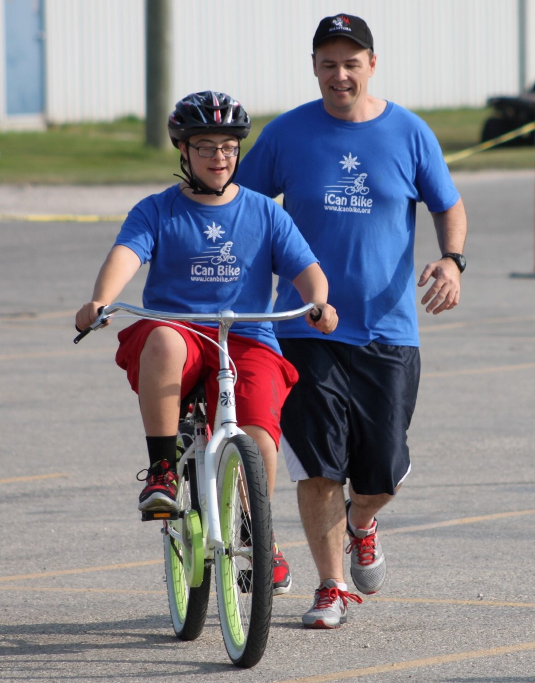

#### Bike Camp For Individuals With Disabilities Comes to East End Arena in Winnipeg the week of July 6th -10th, 2015

#### 

#### 

#### [www.losethetrainingwheels.org](http://www.losethetrainingwheels.org)

# HOW TO REGISTER

# ICan Bike riders are children ages 8 and up, teens and sometimes adults who have a diagnosed disability but able to walk without assistive devices and sidestep from side to side.

Parents, teachers and therapists describe our results as INCREDIBLE. In 2012, by the end of the 5-day camp over 80% of riders learned to ride a conventional bike completely independently. Success in learning to ride a bicycle is a major accomplishment. Learning to ride builds confidence and an improved self-image.

To learn more about how to participate as a rider or volunteer e-mail: icanshinewpg@gmail.com.

**HOW YOU CAN HELP**

**Be a Volunteer**

Be a “spotter” for the same rider for each of the 5 days and experience the thrill of giving the gift of riding a bike! 75 invigorating minutes per day… it just may be the most rewarding exercise and emotional experience you’ve ever had! To volunteer to be a spotter for a rider email: icanshinewpg@gmail.com

**Be a Sponsor**

To support this endeavor contact our camp director Sean and Lori Frain at: icanshinewpg@gmail.com

**Be a Donor**

No donation is too small! Sponsor one child by making a donation of $150

**AN INSPIRATION**

Liam is a 16-year old boy with Downs Syndrome and attended our camp last summer at the East St Paul Arena. He has had numerous challenges in his life, many of which prevented him from learning to ride a bike. After completing an iCan Bike program in Winnipeg, he is NOW riding! Many people like Liam never learn to ride, a skill that lasts a lifetime.

# Imagine the joy that children and adults with disabilities experience when they, too, can ride with their peers and family, opening a world of new experiences!

***...a milestone in life that creates confidence, independence & friendship***

# HOW IT WORKS

# From July 6th to 10th, 2015, iCan Shine’s iCan Bike program will be in Winnipeg to teach individuals with disabilities how to ride a conventional bike and become a lifelong independent rider!

iCan Bike uses a fleet of adapted bicycles, a specialized instructional program and a trained staff to teach individuals with disabilities how to ride a bike. Riders attend the same 75-minute session each day for five consecutive days (M – F) whereby they are physically assisted and encouraged by two volunteer “spotters”.

Over the course of the 5-day camp the adapted bike is adjusted to gradually introduce more instability in an effort to challenge riders at their own individual pace. The week is concluded with a touching and inspiring award ceremony!

